User Guild

# Work Process

1. **Website client**

* Home page
* Film
* Showtimes
* Theaters and price
* Promotion
* Ask and answer
* News

1. **App (Android)**

* Promotion
* Movie Review
* Water corn
* Contact
* Discount code
* Thearter
* Membership card
* Member
* Film
* Room
* Showtime
* Ticket
* Top 3 best sellers ,vaforite

1. **Website admin**

* Home page
* Movie
* News movie
* Account

Login account Admin:kimdat1999@gmail.com pass 123

# GUI DESIGN

# Website Admin

1.Login

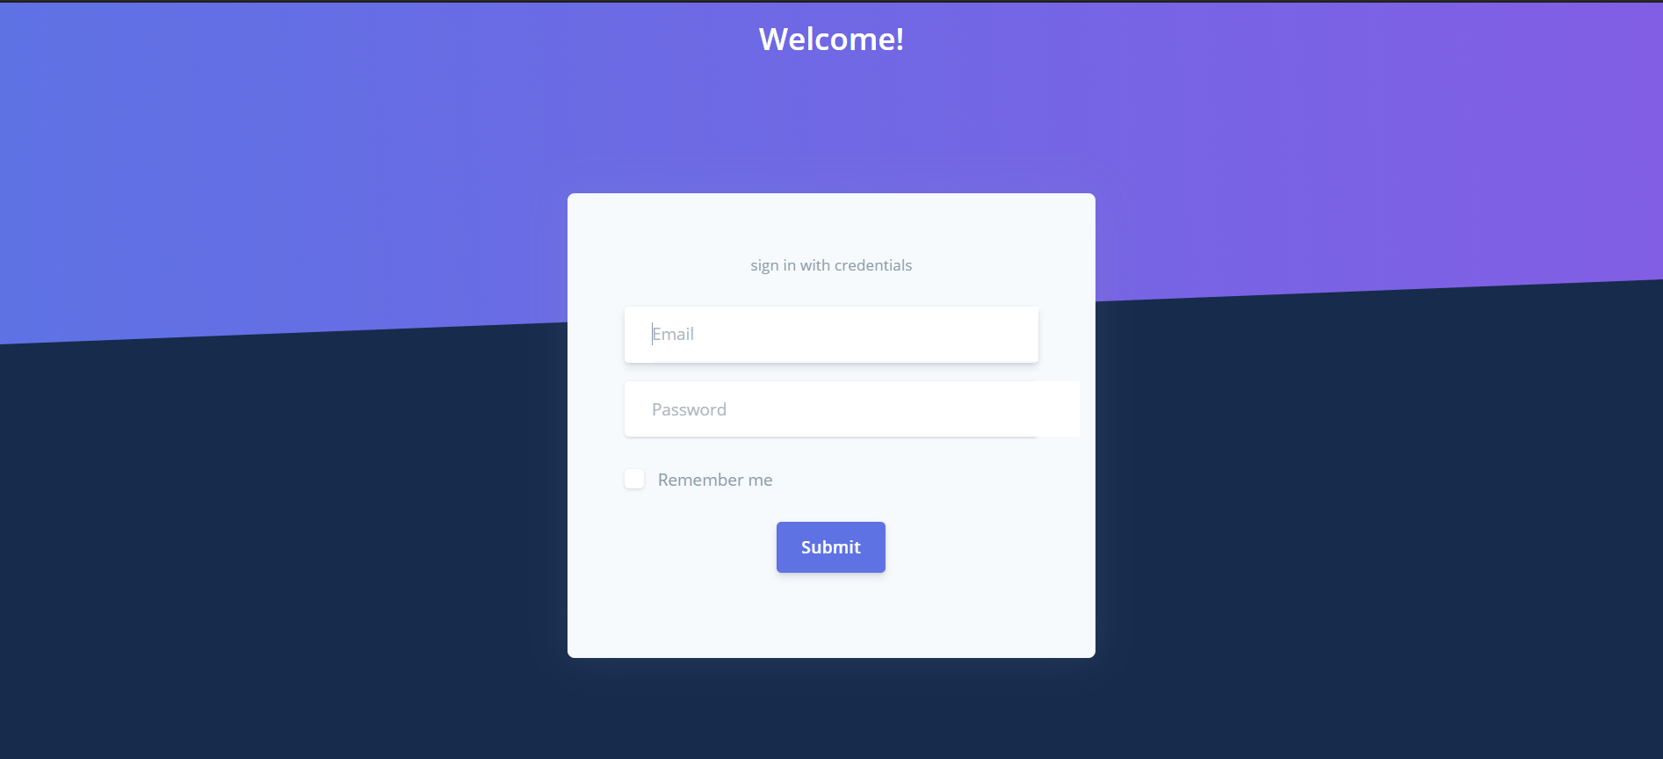

1

3

2

|  |  |  |  |  |  |  |  |
| --- | --- | --- | --- | --- | --- | --- | --- |
| No | Name | Description | | | | | |
| 1 | Email | Click link to go equivalent page | | | | | |
| 2 | Password | Choose the search filter | | | | | |
| 3 | Login | Click to login | | | | | |
|  |  |  |  |  |  |  |

2.Toolbar



|  |  |  |  |  |  |  |
| --- | --- | --- | --- | --- | --- | --- |
| No | Name | Description | | | | |
| 1 | name | Name admin | | | | |
| 2 | Home | Back to home page | | | | |
| 3 | Contact | Button |  | Click | Click to contact page | Enable | |
| 4 | Language | Button |  | Click | Click to call language modal | Enable | |

3.Sidebar

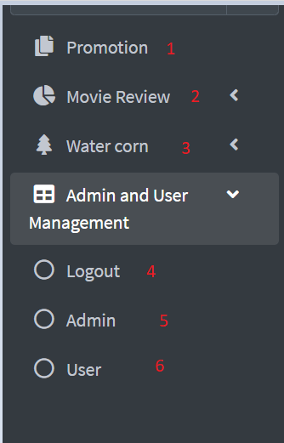

|  |  |  |
| --- | --- | --- |
| No | Name | Description |
| 1 | Promotion | Click to Promotion page |
| 2 | Movie review | Click to movie review page |
| 3 | Water corn | Click to water corn page |
| 4 | Logout | Back to login page |
| 5 | Admin | Click to admin manage page |
| 6 | User | Click to user manage page |

4.Promotion page

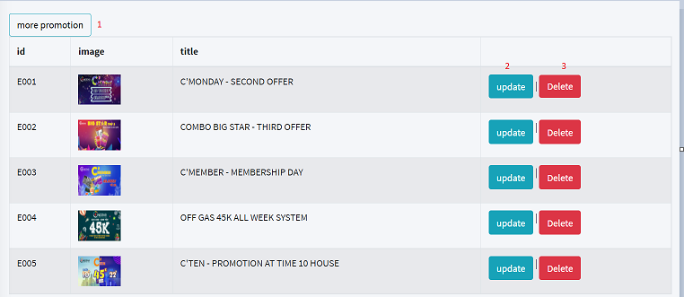

|  |  |  |
| --- | --- | --- |
| No | Name | Description |
| 1 | More promotion | Click to add promotion page |
| 2 | Update | Click to update promotion page |
| 3 | Delete | Click to call confirm delete |

5.Add Promotion page

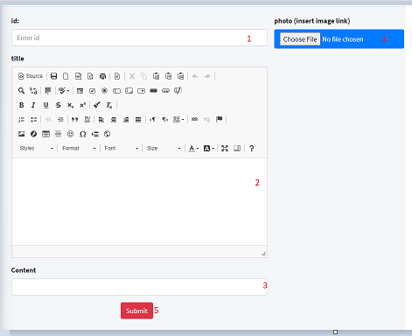

|  |  |  |
| --- | --- | --- |
| No | Name | Description |
| 1 | Id | Input Id of promotion |
| 2 | title | Input title of promotion |
| 3 | content | Input content of promotion |
| 4 | photo | Upload photo of promotion |
| 5 | submit | Click to add information to database |

6.Update Promotion page:

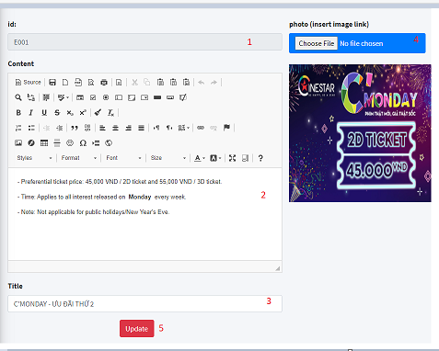

|  |  |  |
| --- | --- | --- |
| No | Name | Description |
| 1 | Id | Id of promotion |
| 2 | title | Input title of promotion |
| 3 | content | Input content of promotion |
| 4 | photo | Upload photo of promotion |
| 5 | update | Click to save information to database |

7.Movie review page:

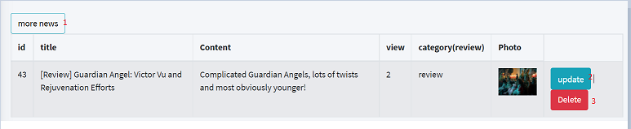

|  |  |  |
| --- | --- | --- |
| No | Name | Description |
| 1 | More news | Click to add movie review page |
| 2 | Update | Click to update movie review page |
| 3 | Delete | Click to call confirm delete |

8.Add movie review page:

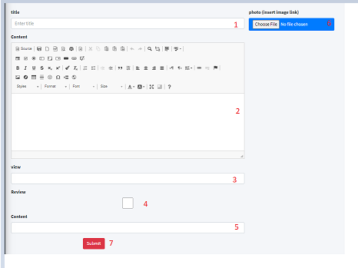

|  |  |  |
| --- | --- | --- |
| No | Name | Description |
| 1 | title | Input title of movie review |
| 2 | content | Input content of movie review |
| 3 | view | Input view of movie review |
| 4 | review | check type movie |
| 5 | Sub content | Input sub content of movie review |
| 6 | photo | Upload photo of movie review |
| 7 | submit | Click to add information to database |

9.Update movie review page:

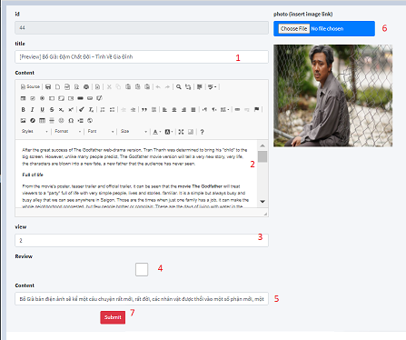

|  |  |  |
| --- | --- | --- |
| No | Name | Description |
| 1 | title | Input title of movie review |
| 2 | content | Input content of movie review |
| 3 | view | Input view of movie review |
| 4 | review | check type movie |
| 5 | Sub content | Input sub content of movie review |
| 6 | photo | Upload photo of movie review |
| 7 | submit | Click to save information to database |

1. Water corn page:

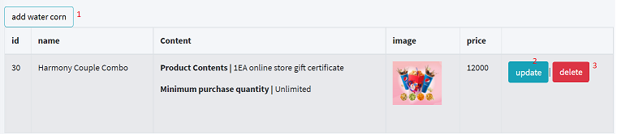

|  |  |  |
| --- | --- | --- |
| No | Name | Description |
| 1 | Add water corn | Click to add water corn page |
| 2 | Update | Click to update water corn page |
| 3 | Delete | Click to call confirm delete |

1. Add water corn page:

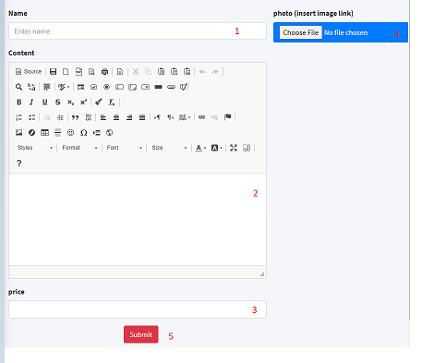

|  |  |  |
| --- | --- | --- |
| No | Name | Description |
| 1 | name | Input name of water corn |
| 2 | content | Input content of water corn |
| 3 | price | Input price of water corn |
| 4 | photo | Upload photo of water corn |
| 5 | Submit | Click to add information to database |

1. Update water corn page:

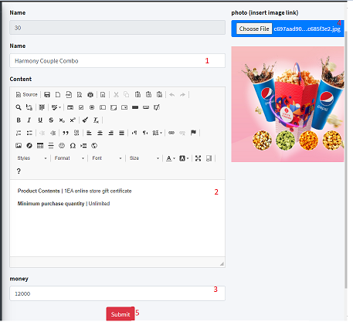

|  |  |  |
| --- | --- | --- |
| No | Name | Description |
| 1 | name | Input name of water corn |
| 2 | content | Input content of water corn |
| 3 | price | Input price of water corn |
| 4 | photo | Upload photo of water corn |
| 5 | Submit | Click to save information to database |

1. Confirm delete (review movie,water corn,promotion):

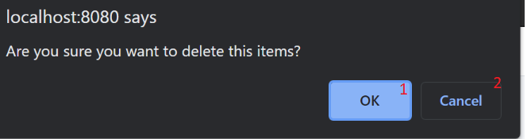

|  |  |  |
| --- | --- | --- |
| No | Name | Description |
| 1 | Ok | Click to delete item |
| 2 | cancel | Click to close |

### 14.ManageCoupon page

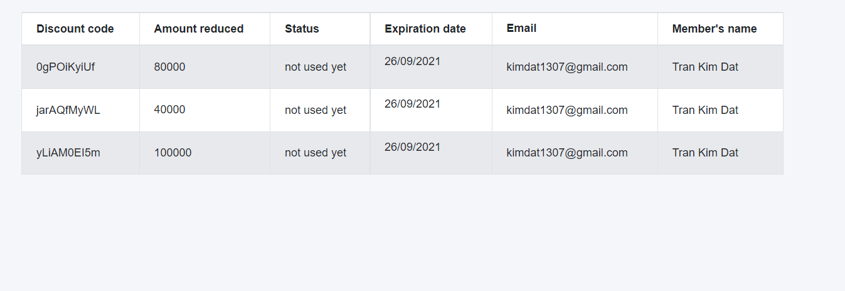

### 15.Search coupon(by code,email,name)

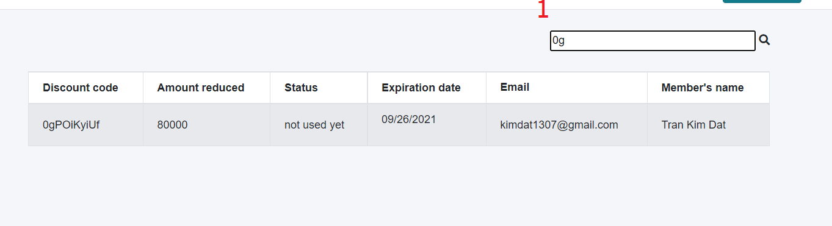

|  |  |  |
| --- | --- | --- |
| No | Name | Description |
| 1 | search | Input name,email member’s or discount code |

### 16.Manage list User Page

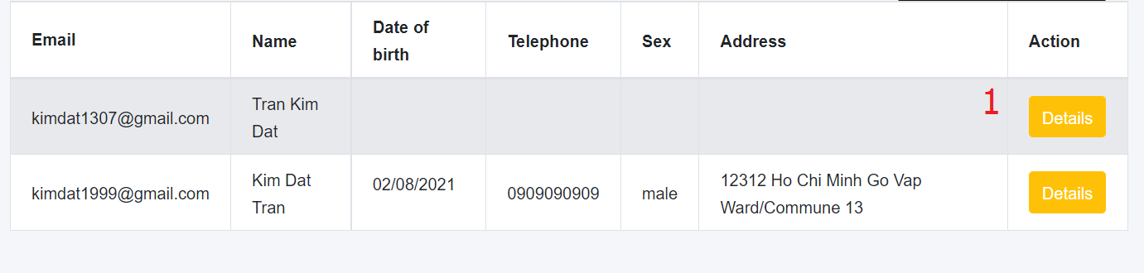

|  |  |  |
| --- | --- | --- |
| No | Name | Description |
| 1 | detail | Href to page detail |

### 17.Search user

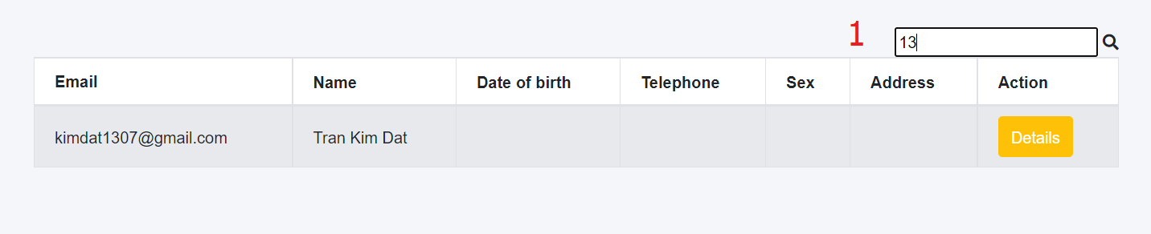

|  |  |  |
| --- | --- | --- |
| No | Name | Description |
| 1 | search | Search by name or email |

### 18.Manage User detail and membershipcard’s user

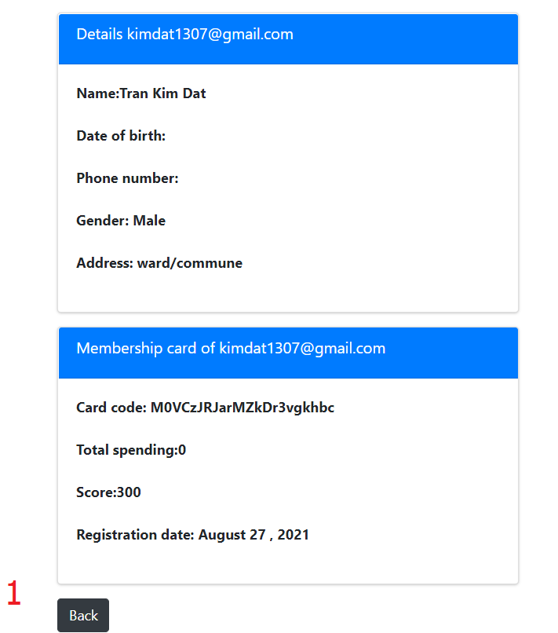

|  |  |  |
| --- | --- | --- |
| No | Name | Description |
| 1 | back | Click back to manage user |

### 19.Manage membershipcard page

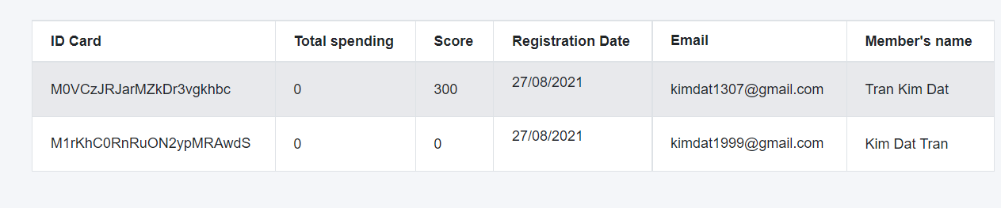

### 20.Search membershipcard

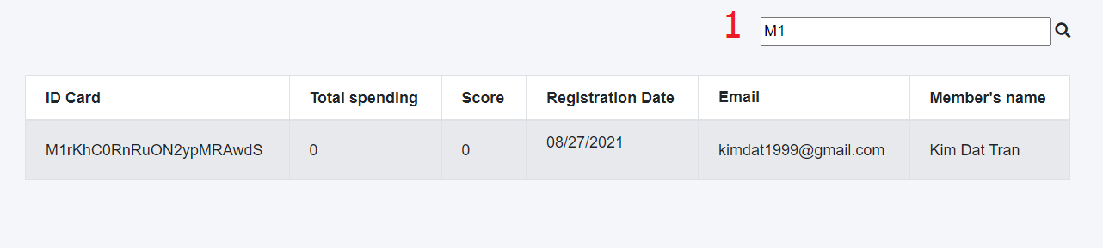

|  |  |  |  |  |  |  |
| --- | --- | --- | --- | --- | --- | --- |
| No | Name | Type | Validation | Event | Description | Status |
| 1 | search | textbox |  | keyup | Search by member’s name or email or idcard | Enable |

### 21.Manage threater page

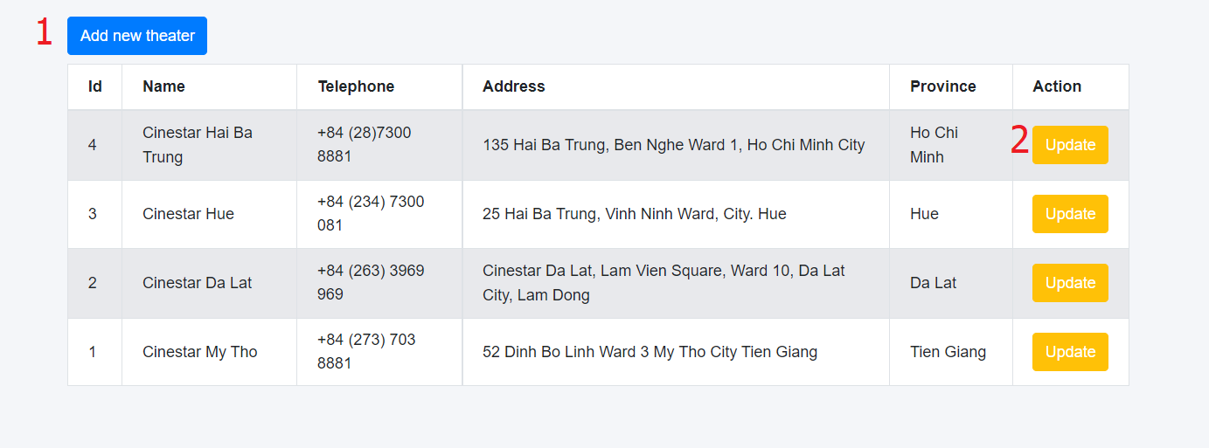

|  |  |  |
| --- | --- | --- |
| No | Name | Description |
| 1 | Add | Click to add threater |
| 2 | Update | Click to update threater |

### 22.Add threater

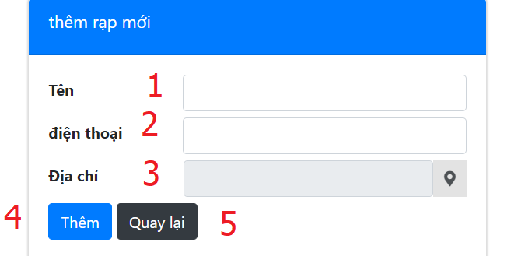

|  |  |  |
| --- | --- | --- |
| No | Name | Description |
| 1 | Name | Input name |
| 2 | Phone | Input phone |
| 3 | Address | Input address |
| 4 | Back | Click to back manage threater |
| 5 | location | Click to open modal |

### 23.Modal here api

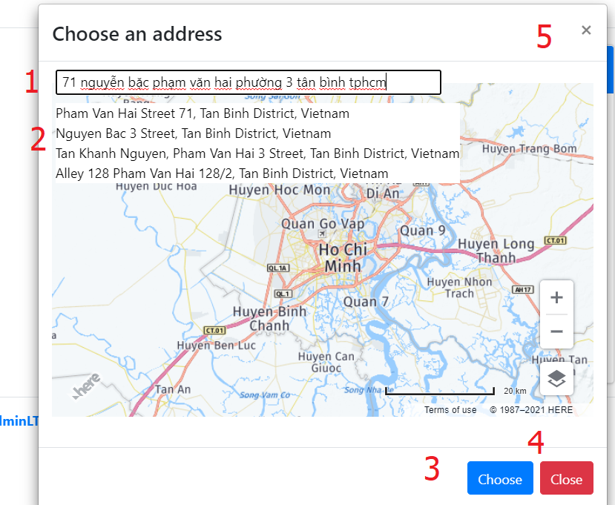

|  |  |  |
| --- | --- | --- |
| No | Name | Description |
| 1 | Search | Input search |
| 2 | Panel | Choose address to see location in google |
| 3 | Choose | Click to confirm choose address |
| 4 | Close | Click close modal |
| 5 | Close | Click close modal |

### 24.Update threater

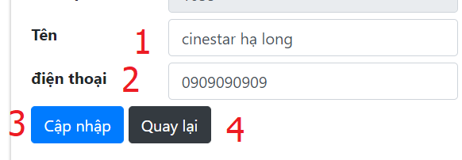

|  |  |  |
| --- | --- | --- |
| No | Name | Description |
| 1 | Name | Input name |
| 2 | Phone | Input phone |
| 3 | Update | Add threater |
| 4 | Back | Click to back manage threater |

### 25.Manage ratingthreater

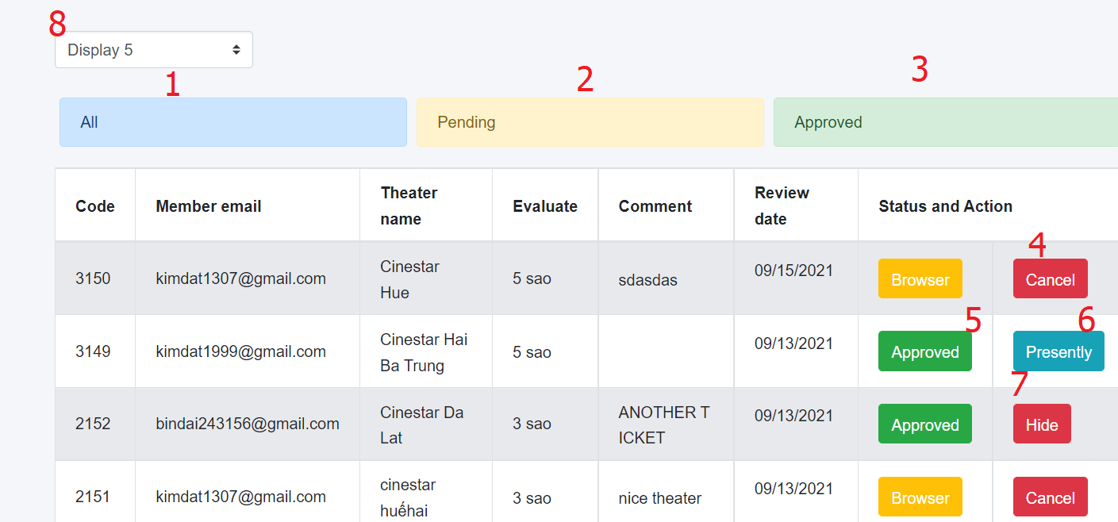

|  |  |  |
| --- | --- | --- |
| No | Name | Description |
| 1 | All | Click to show all |
| 2 | Pending | Click to show pending |
| 3 | Approved | Click to show approvd |
| 4 | Cancel | Click to cancel comment |
| 5 | bro | Click to show approvd |
| 4 | Cancel | Click to don’t approve comment |
| 5 | Approve | Click to approve comment |
| 6 | Show | Click to show comment |
| 7 | Hide | Click to Hide comment |
| 8 | display | Choose number item show earch page |

### 26.Report top 3 movies

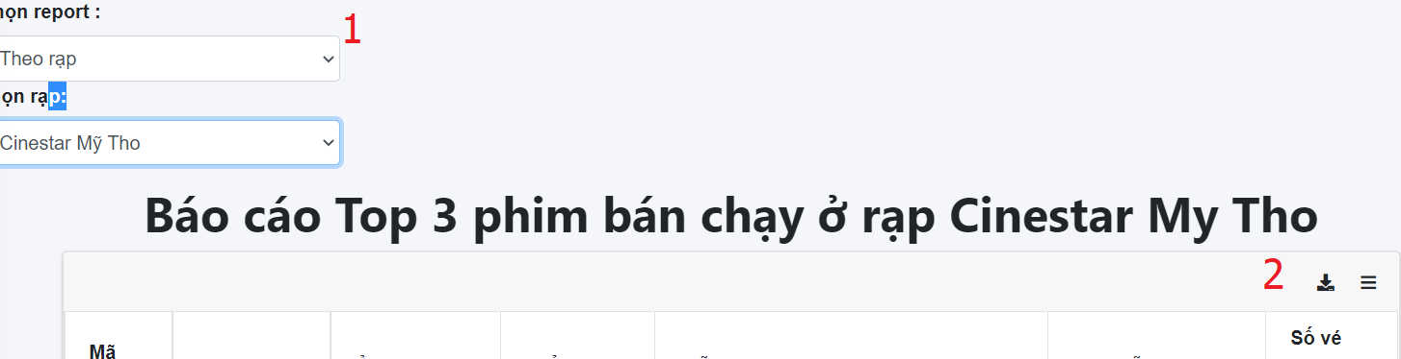

|  |  |  |
| --- | --- | --- |
| No | Name | Description |
| 1 | Type | Choose type report |
| 2 | print | Click to print report |

### 27.Report deatil spending user

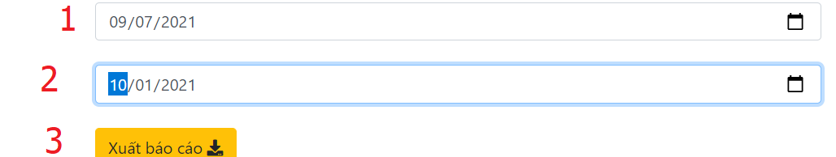

|  |  |  |
| --- | --- | --- |
| No | Name | Description |
| 1 | fromdate | Click to choose from date |
| 2 | todate | Click to choose to date |
| 3 | print | Click to print report |

### 28.Send email for member registed to receive news

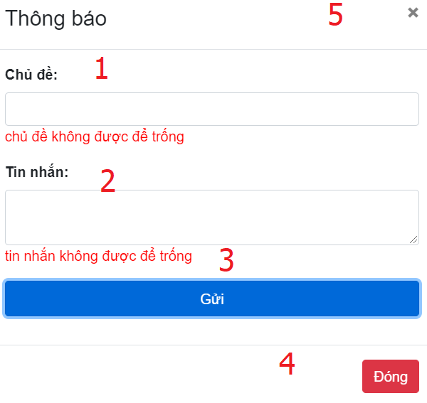

|  |  |  |
| --- | --- | --- |
| No | Name | Description |
| 1 | subject | Subject email |
| 2 | message | Mess email |
| 3 | send | Click to send email |
| 4,5 | Close | Click to close modal |

### 29. Manage movie page

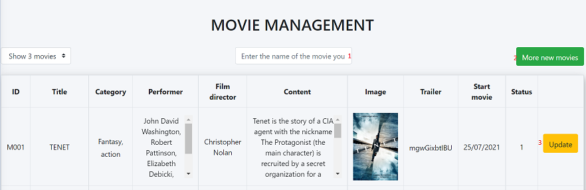

|  |  |  |
| --- | --- | --- |
| No | Name | Description |
| 1 | Search | Search movie |
| 2 | Add new movie | Click to add new movie |
| 3 | Update | Click to update movie |

### 30. Add movie page

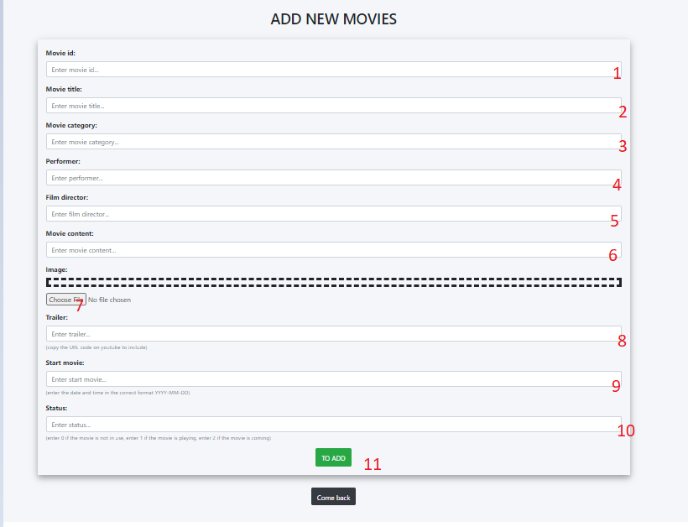

|  |  |  |  |
| --- | --- | --- | --- |
| No | Name | Description | Status |
| 1 | Movie Id | Input Id movie | Enable |
| 2 | Movie title | Input title of movie | Enable |
| 3 | Movie category | Input category of movie | Enable |
| 4 | Performer | Input performer of movie | Enable |
| 5 | Flim director | Input director of movie | Enable |
| 6 | Movie contennt | Input content of movie | Enable |
| 7 | imgae | Upload photo of water corn | Enable |
| 8 | Trailler | Input Trailer of movie | Enable |
| 9 | Start movie | Input day start of movie | Enable |
| 10 | status | Input status of movie | Enable |
| 11 | Submit | Click to add information to database | Enable |

### 31. Manage ticket page

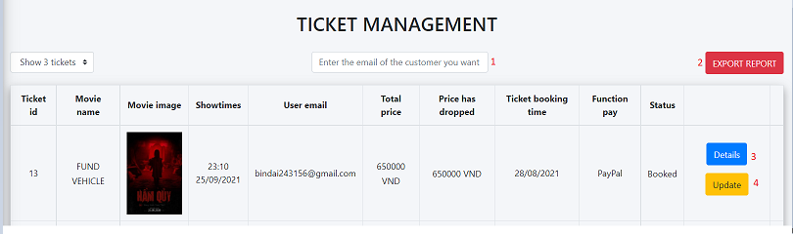

|  |  |  |
| --- | --- | --- |
| No | Name | Description |
| 1 | Search | Search email |
| 2 | Export report | Click to page report page |
| 3 | detail | Click to detail ticket page |
| 4 | update | Click to update ticket page |

### 32. Report ticket page

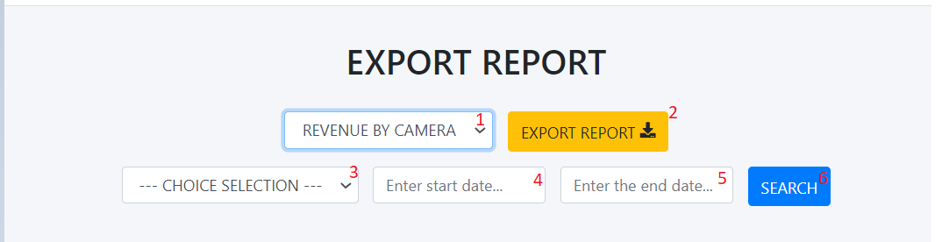

|  |  |  |
| --- | --- | --- |
| No | Name | Description |
| 1 | Revenue by camera | Select revenue |
| 2 | Export report | Click to export report to file pdf |
| 3 | Choise selet | Select choise |
| 4 | Start date | Input start date |
| 5 | End date | Input end date |
| 6 | Search | Click search report |

### 33. Manage Room page

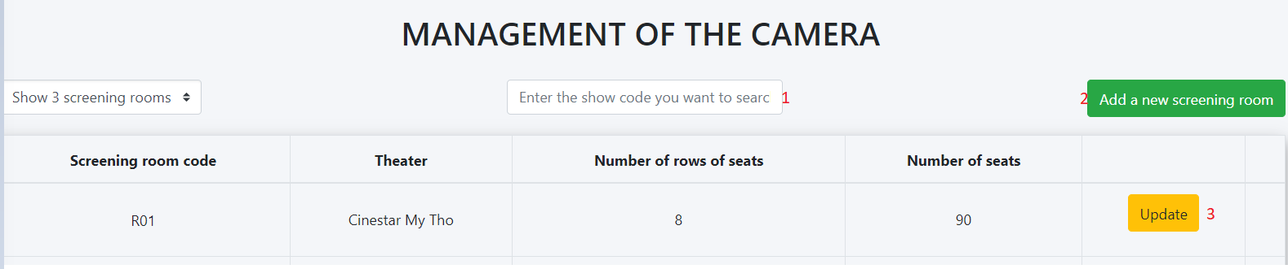

|  |  |  |
| --- | --- | --- |
| No | Name | Description |
| 1 | Search | Search Room |
| 2 | Add new Room | Click to add new room page |
| 3 | update | Click to update room page |

### 34. Add new room page

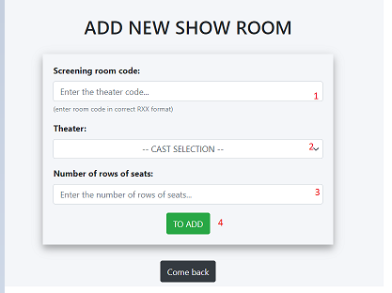

|  |  |  |
| --- | --- | --- |
| No | Name | Description |
| 1 | Screning room | Input screening room code |
| 2 | Theater | Select theater |
| 3 | Number of rows of seast | Input number of rows |

### 35. Report top 5 buyer

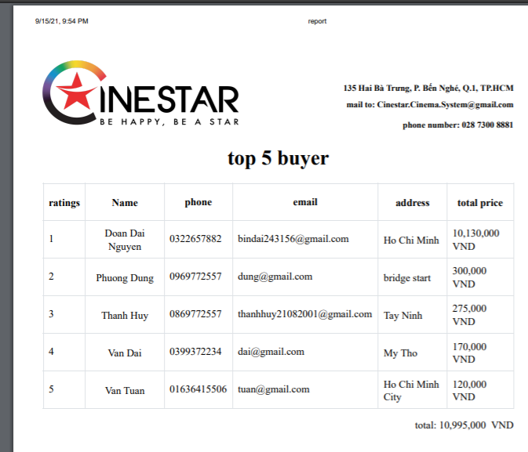

### 36. Update Movie

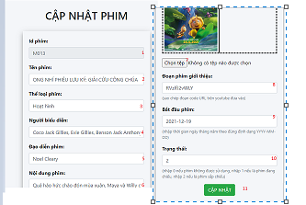

|  |  |  |
| --- | --- | --- |
| No | Name | Description |
| 1 | ID | Id of movie |
| 2 | Name movie | Input name movie |
| 3 | Category movie | Input category movie |
| 4 | Cast movie | Input cast movie |
| 5 | Director movie | Input director movie |
| 6 | Content movie | Input content movie |
| 7 | Image movie | Choose file image movie |
| 8 | Trailler movie | Input link trailer movie |
| 9 | Start time | Input start time movie |
| 10 | End time | Input end time movie |
| 11 | update | Click to update movie |

### 37. update ticket

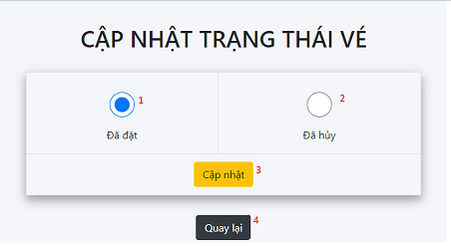

|  |  |  |
| --- | --- | --- |
| No | Name | Description |
| 1 | Booked | Click to choose booket |
| 2 | cancelled | Click to choose cancelled |
| 3 | update | Click to update ticket |

### 38.Showtimes page

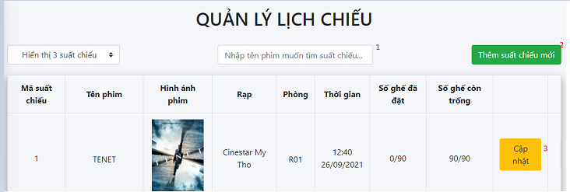

|  |  |  |
| --- | --- | --- |
| No | Name | Description |
| 1 | Search | Search Room |
| 2 | Add new showtimes | Click to add new showtimes page |
| 3 | update | Click to update room page |

### 39 Add new showtimes

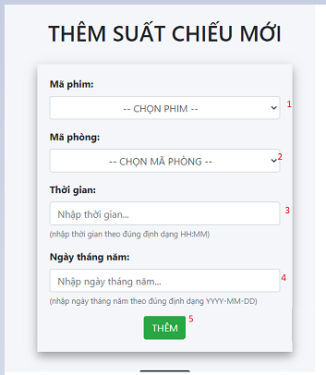

|  |  |  |
| --- | --- | --- |
| No | Name | Description |
| 1 | Movie code | Select choose movie code |
| 2 | Movie room | Select choose room |
| 3 | time | Input time of showtimes |
| 4 | Day month year | Input Day month year of showtimes |
| 5 | add | Click to add showtimes |

### 40.Update Showtimes

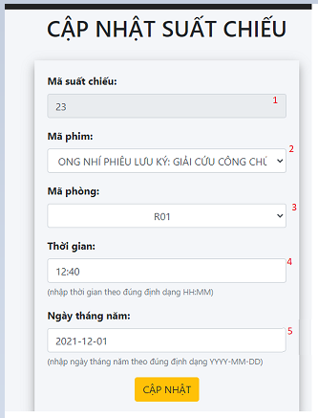

|  |  |  |
| --- | --- | --- |
| No | Name | Description |
| 1 | Movie code | Select choose movie code |
| 2 | Movie room | Select choose room |
| 3 | time | Input time of showtimes |
| 4 | Day month year | Input Day month year of showtimes |
| 5 | update | Click to update showtimes |

### 41.update room

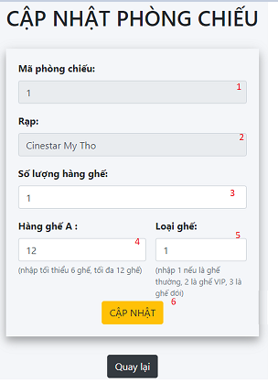

|  |  |  |
| --- | --- | --- |
| No | Name | Description |
| 1 | room code | Input room code |
| 2 | Theater | Input theater |
| 3 | Number of seats | Input number of seats |
| 4 | Row of seats | Input row of seats |
| 5 | Type of seats | Input type of seats |
| 6 | update | Click to update room |

42. Detail ticket page

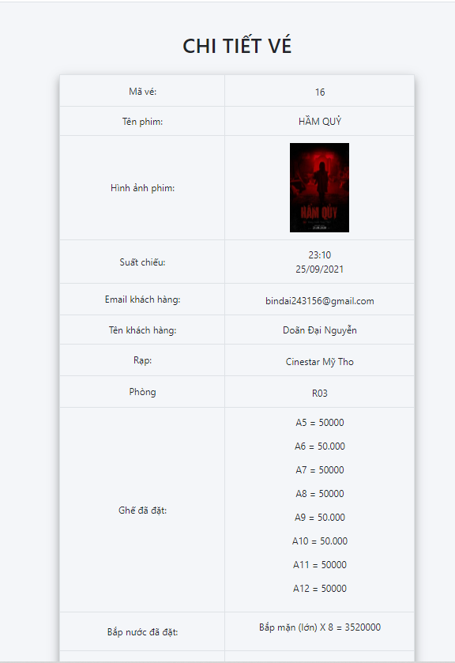

# Website Client

1. Home page

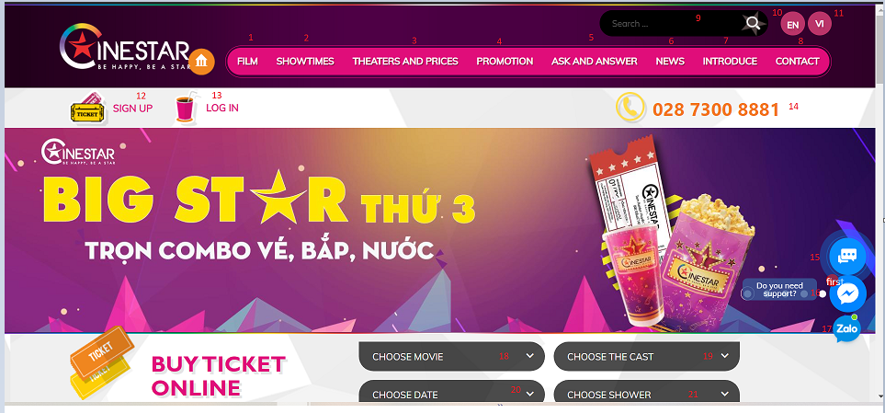

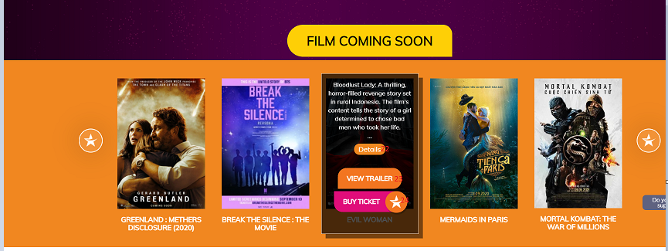

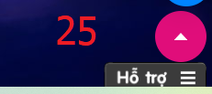

|  |  |  |
| --- | --- | --- |
| No | Name | Description |
| 1 | Flim | Click to Film page |
| 2 | Showtime | Click to Showtime page |
| 3 | Theaters and prices | Click to Theaters and prices page |
| 4 | promotion | Click to promotion page |
| 5 | Ask and answer | Click to Ask and answer page |
| 6 | News | Click to News page |
| 7 | Introduce | Click to Introduce page |
| 8 | Contact | Click to Contact page |
| 9 | Search | Search movie |
| 10 | EN | Click to change language to English |
| 11 | VI | Click to change language to Vietnamese |
| 12 | Sign up | Click to sign up page |
| 13 | Login | Click to login page |
| 14 | phone | Click to call |
| 15 | Vchat | Click to open chat bubble |
| 16 | Facebook chat | Click to open chat bubble |
| 17 | Zalo chat | Click to open chat bubble |
| 18 | Choose movie | Choose movie |
| 19 | Choose the cast | Choose cast |
| 20 | Choose date | Choose date |
| 21 | Choose shower | Choose shower |
| 22 | detail | Click to page detail movie |
| 23 | View trailer | Click to open modal video trailer |
| 24 | Buy ticket | Click to ticket page |
| 25 | uhchat | Click to open chat bubble |

1. Promation page:

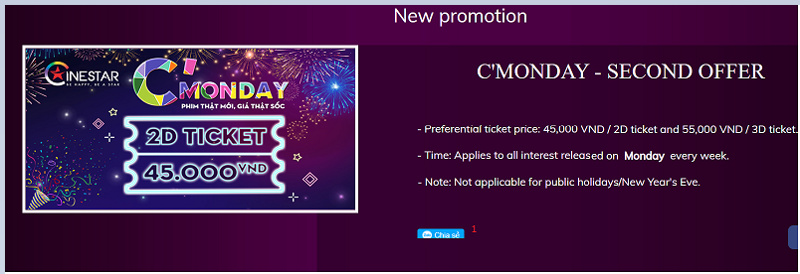

|  |  |  |
| --- | --- | --- |
| No | Name | Description |
| 1 | Share zalo | Share page |

1. News page

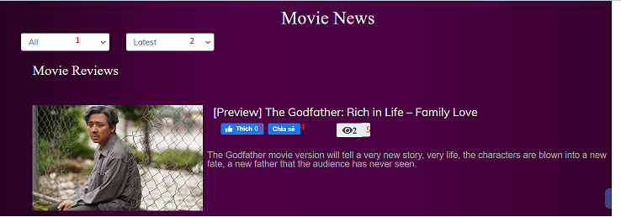

|  |  |  |
| --- | --- | --- |
| No | Name | Description |
| 1 | Search type | Click to search type |
| 2 | Search latest and view | Click to search latest and view |
| 3 | Like facebook | Click to like items |
| 4 | Share facebook | Click to share facebook |
| 5 | view | See the number of people visiting the page |

1. Contact page

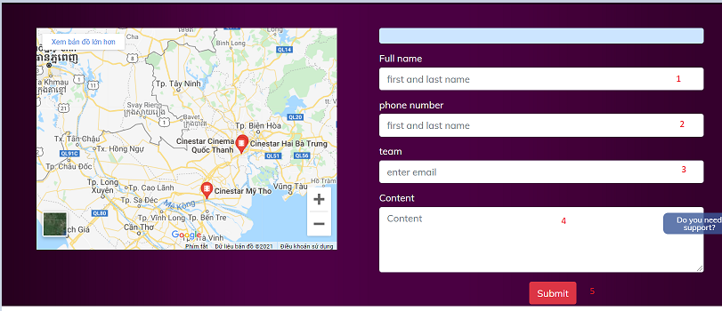

|  |  |  |
| --- | --- | --- |
| No | Name | Description |
| 1 | Full name | Input name of contact |
| 2 | Phone number | Input phone of contact |
| 3 | email | Input email of contact |
| 4 | Content | Input content of contact |
| 5 | send | Send contact to admin |

1. Showtimes page

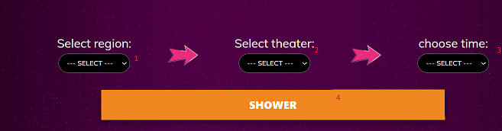

|  |  |  |
| --- | --- | --- |
| No | Name | Description |
| 1 | Select region | choose region |
| 2 | Select theater | choose theater |
| 3 | Choose time | choose time |
| 4 | Shower | Click to shower modal |

1. Book ticket

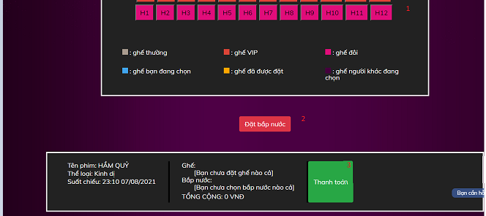

|  |  |  |
| --- | --- | --- |
| No | Name | Description |
| 1 | Choose seat | Click to choose seat |
| 2 | Oder water corn | Click to open oder water corn |
| 3 | pay | Click to pay page |

### 7.Find nearest threater,find nearly threater

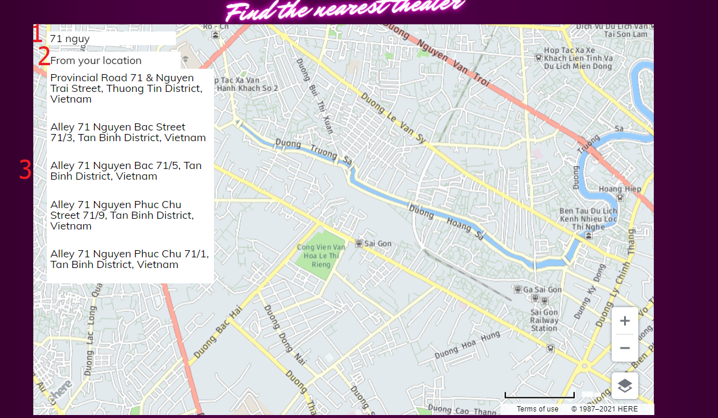

|  |  |  |
| --- | --- | --- |
| No | Name | Description |
| 1 | Search | Input search |
| 2 | Location | Get location current |
| 2 | Panel | Choose address to see location in google |

### 8.Threater page

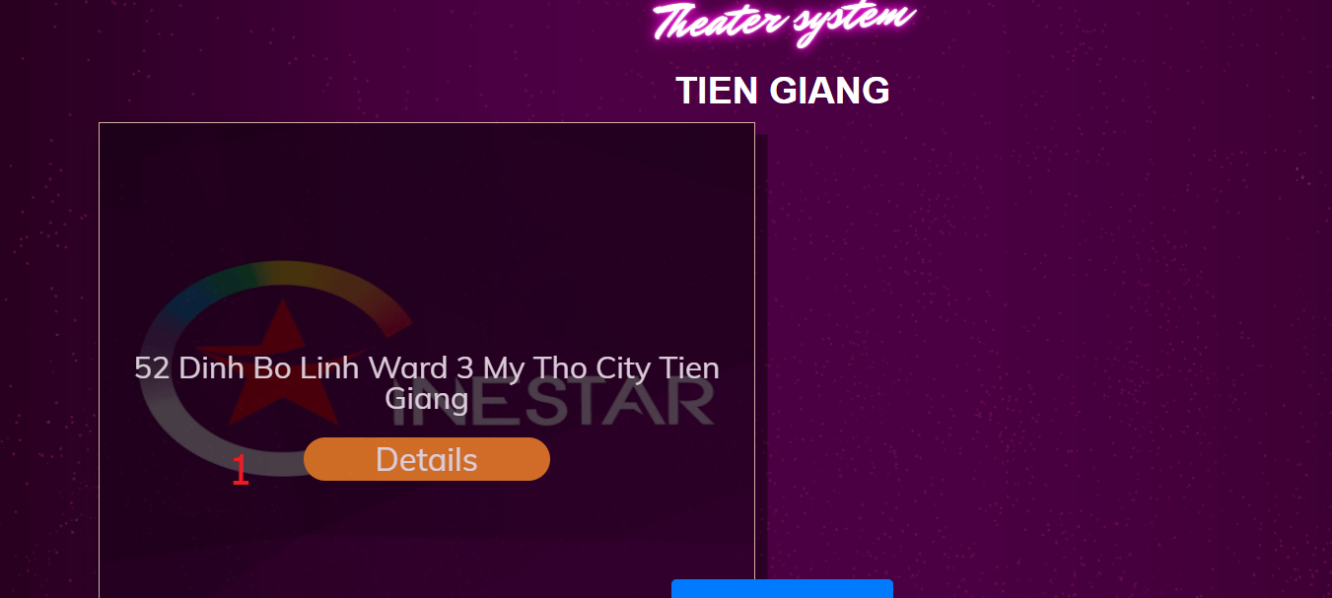

|  |  |  |
| --- | --- | --- |
| No | Name | Description |
| 1 | Detail | Href to detail threat |

### 9.Threater detail page

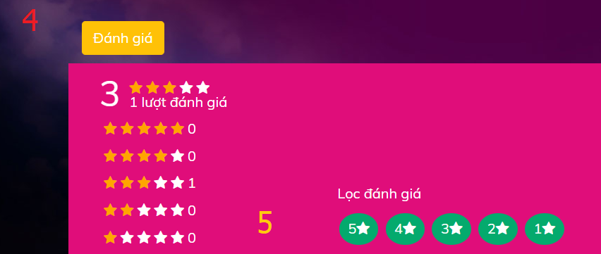

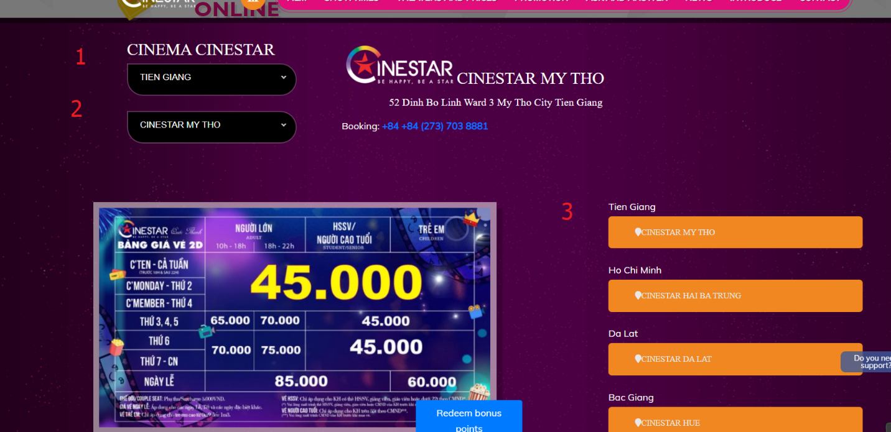

|  |  |  |
| --- | --- | --- |
| No | Name | Description |
| 1 | province | Select province |
| 2 | Name threater | Select name threater |
| 3 | Link threater | Href to another threater |
| 4 | Rating | Click to show modal rating |
| 5 | Display | Click to choose show filter by rating number |

### 10.Mini game

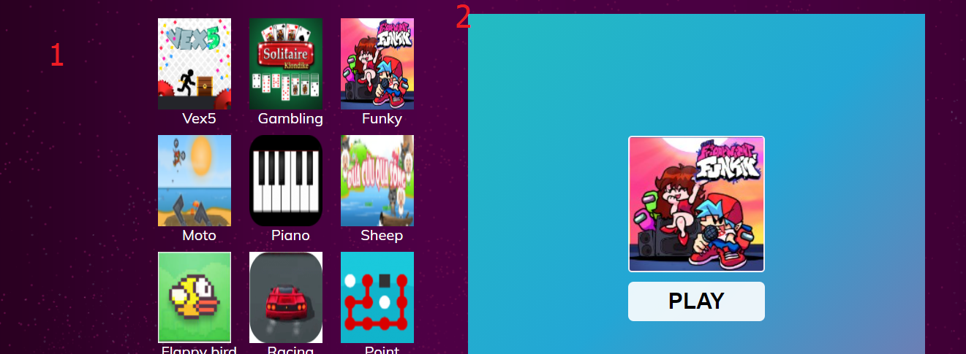

|  |  |  |
| --- | --- | --- |
| No | Name | Description |
| 1 | Image game | Click to choose game |
| 2 | Game |  |

### 11.Register receiver news

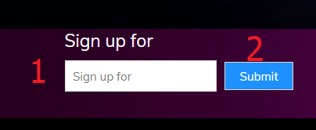

|  |  |  |
| --- | --- | --- |
| No | Name | Description |
| 1 | Sign up | Input email |
| 2 | submit | Click to send |

### 12.pop up fchat

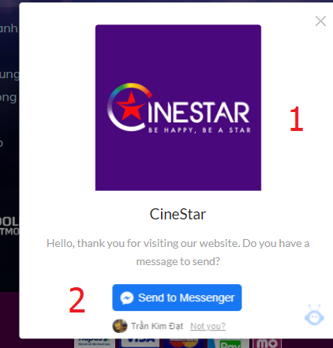

|  |  |  |
| --- | --- | --- |
| No | Name | Description |
| 1 | Close | Close popup |
| 2 | Send | Click to send |

### 13.Login

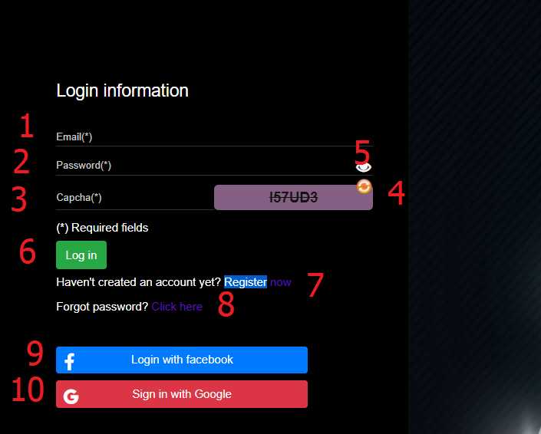

|  |  |  |
| --- | --- | --- |
| No | Name | Description |
| 1 | Email | Input email |
| 2 | password | Input password |
| 3 | Captcha | Input capcha |
| 4 | Recapcha | Click to change recapcha |
| 5 | password | Show/hide password |
| 6 | login | Click to login |
| 7 | Register/login | Slide to register |
| 8 | Forgotpass | Click show modal forgotpass |
| 9 | Login facebook | Click to login facebook |
| 10 | Login google | Click to login google |

### 14.Register

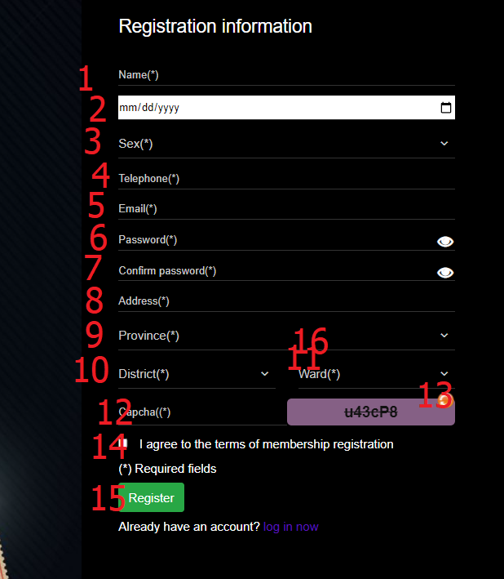

|  |  |  |
| --- | --- | --- |
| No | Name | Description |
| 1 | Name | Input name |
| 2 | Date of birth | Datebox date of birth |
| 3 | Sex | Select gender |
| 4 | phone | Input phone |
| 5 | email | Input email |
| 6 | password | Input pass |
| 7 | confirmpassword | Input confirm |
| 8 | Address | Input address |
| 9 | Province | Select province |
| 10 | District | Select district |
| 11 | Ward | Select ward |
| 12 | Captcha | Input capcha |
| 13 | Recapcha | Click to change recapcha |
| 14 | agree | Click to addgree |
| 15 | register | Click to register |
| 16 | Register/login | Slide to login |

### 15.forgot password

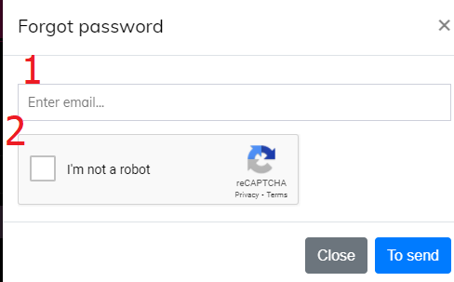

|  |  |  |
| --- | --- | --- |
| No | Name | Description |
| 1 | email | Input email |
| 2 | Not robot | Click to confirm I’m not a robot |

### 16.Reset password

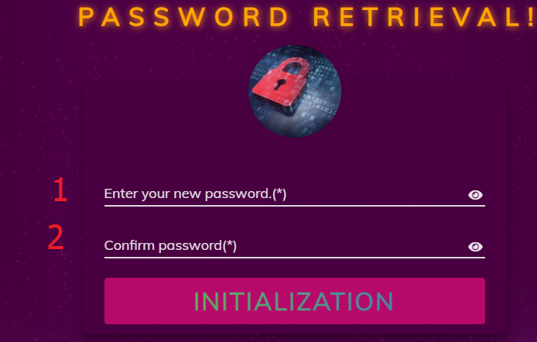

|  |  |  |
| --- | --- | --- |
| No | Name | Description |
| 1 | password | Input pass |
| 2 | confirmpassword | Input confirm |

### 17.Rating,add/remove this movie personal movie wishlist ,share link movie detail in zalo

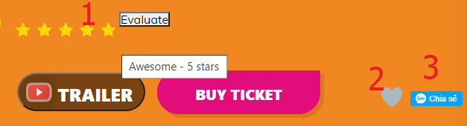

|  |  |  |
| --- | --- | --- |
| No | Name | Description |
| 1 | rating | Click to rating |
| 2 | heart | Click to add/remove this movie personal movie wishlist |
| 3 | Share zalo | Click to share link movie detail |

### 18.Change coupon

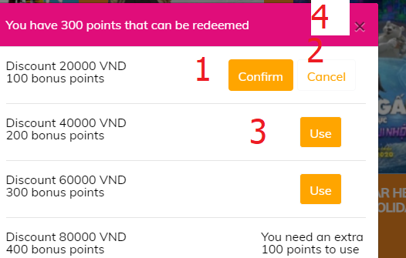

|  |  |  |
| --- | --- | --- |
| No | Name | Description |
| 1 | use | Click to choose point want change |
| 2 | cancel | Click to cancel |
| 3 | confirm | Click to confirm change |
| 4 | close | Click to close modal |

### 19.order history

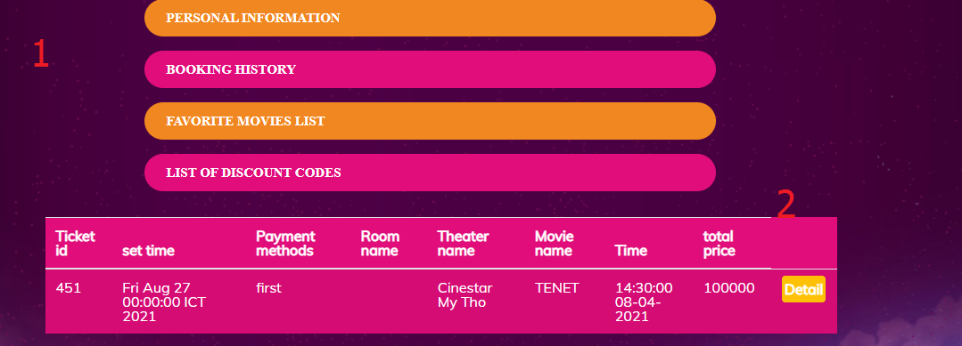

|  |  |  |
| --- | --- | --- |
| No | Name | Description |
| 1 | About personal slide | Click to href |
| 2 | Detail | Click to see detail ticket |

### 20.Detail ticket

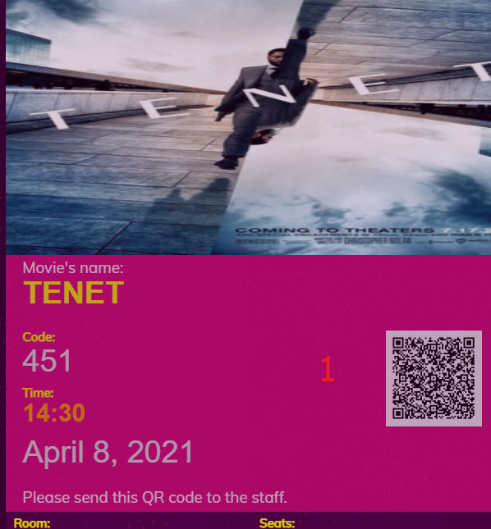

|  |  |  |
| --- | --- | --- |
| No | Name | Description |
| 1 | qrcode | Show detail ticket |

### 21.List personal coupon

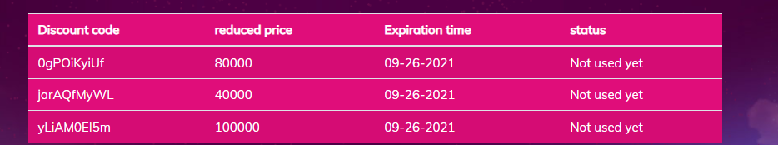

### 22.personal movie wishlist , personal watched movie

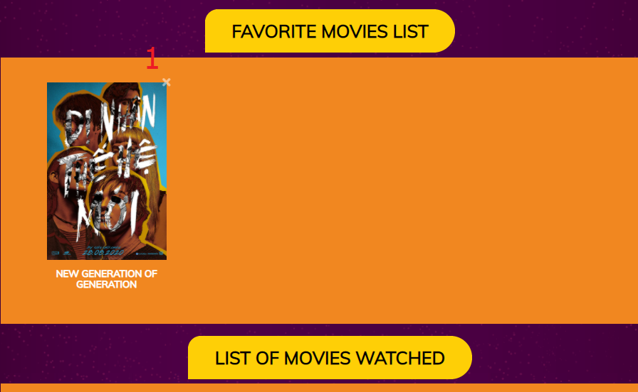

|  |  |  |
| --- | --- | --- |
| No | Name | Description |
| 1 | remove | Click remove this movie out of personal movie wishlist |

### 23.personal information

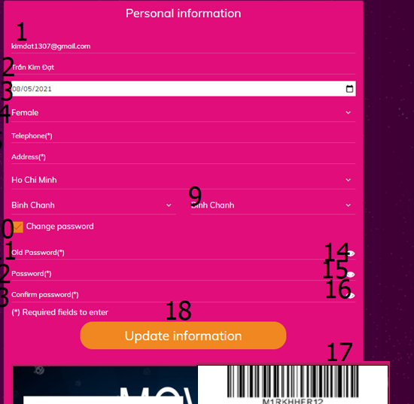

|  |  |  |
| --- | --- | --- |
| No | Name | Description |
| 1 | email | Input email(Read only) |
| 2 | Name | Input name |
| 3 | Date of birth | Datebox date of birth |
| 4 | Sex | Select gender |
| 5 | phone | Input phone |
| 6 | Address | Input address |
| 7 | Province | Select province |
| 8 | District | Select district |
| 9 | Ward | Select ward |
| 10 | changepass | Click to show /hide div change password |
| 11 | oldpass | Input old pass |
| 12 | password | Intput password |
| 13 | confirm | Input confirm |
| 14,15,16 | Show/hide password | Click to show/hide password |
| 17 | bacode | See bar code |
| 18 | update | Click to update personal information |

### 24.Rating threater

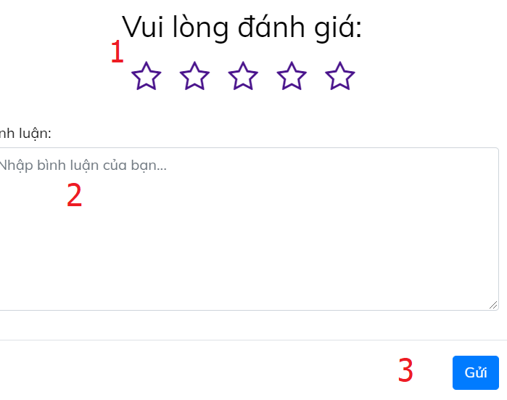

|  |  |  |
| --- | --- | --- |
| No | Name | Description |
| 1 | rating | Click to choose number rating |
| 2 | comment | Input comment |

### 25.Notification



### 26. Payment page

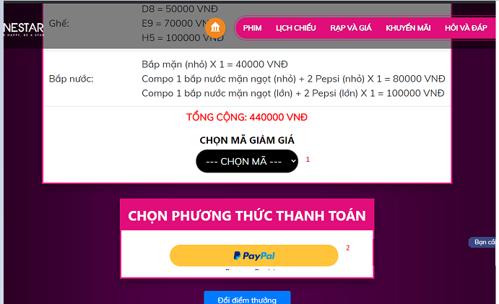

|  |  |  |
| --- | --- | --- |
| No | Name | Description |
| 1 | Choose discount code | Select choose discountcode |
| 2 | paypal | Click to pay ticket |

### 27.Vchat

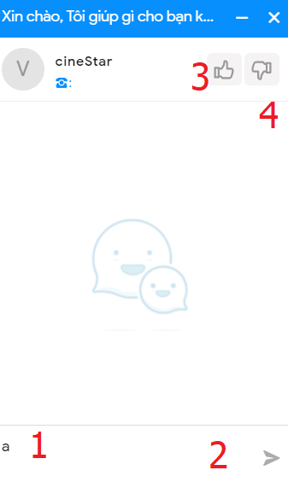

|  |  |  |
| --- | --- | --- |
| No | Name | Description |
| 1 | textarea | Input mess,Enter to send mess |
| 2 | send | Click to send mess |
| 3,4 | Like,dislike | Click to like/dislike |

### 28.Facebookchat

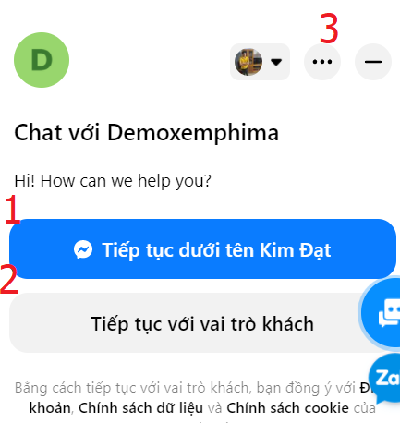

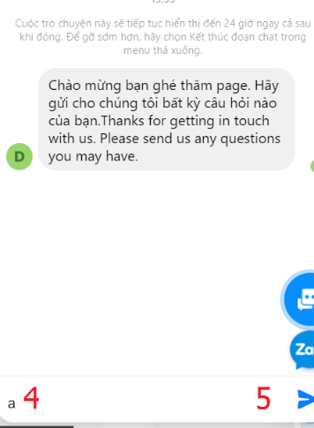

|  |  |  |
| --- | --- | --- |
| No | Name | Description |
| 1 | facebookaccount | Click to continue chat as facebook account |
| 2 | guest | Click to continue chat as guest |
| 3 | close | Click to close box chat |
| 4 | textarea | Input mess |
| 5 | send | Click to send mess |

### 29.zalo chat

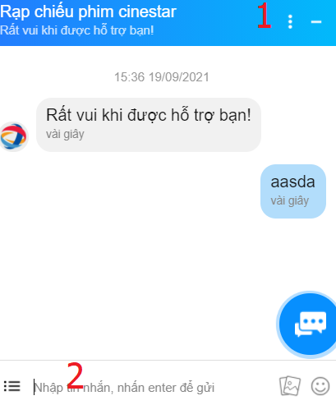

|  |  |  |
| --- | --- | --- |
| No | Name | Description |
| 1 | close | Click to close box chat |
| 2 | textarea | Input mess, enter to send mess |

### 30.Uhchat

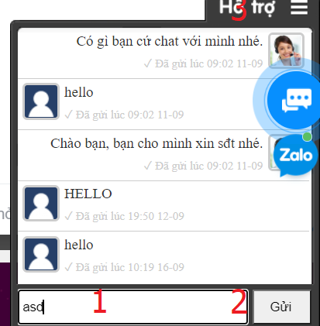

|  |  |  |
| --- | --- | --- |
| No | Name | Description |
| 1 | textarea | Input mess, enter to send mess |
| 2 | send | Click to send mess |
| 3 | close | Click to close box chat |

31. search movie page

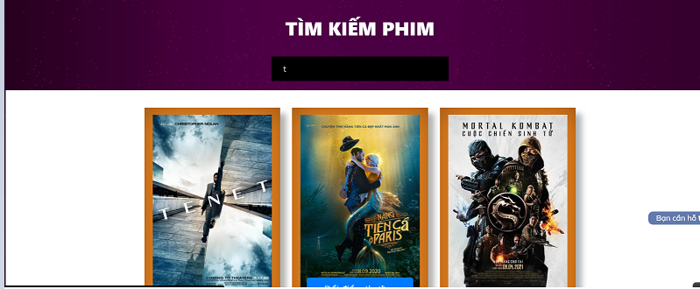

|  |  |  |
| --- | --- | --- |
| No | Name | Description |
| 1 | Search | Search movie |

32. Movie page

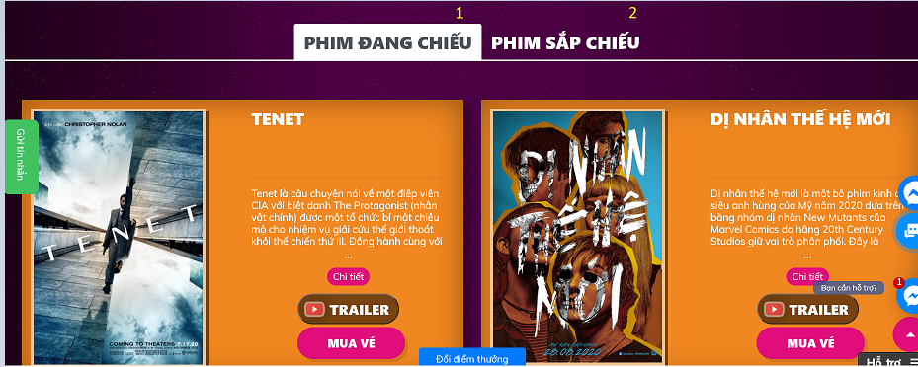

|  |  |  |
| --- | --- | --- |
| No | Name | Description |
| 1 | Movies Showing | Click to movies showing |
| 2 | Film coming soon | Click to film coming soon |

# App (android)

1. Home page

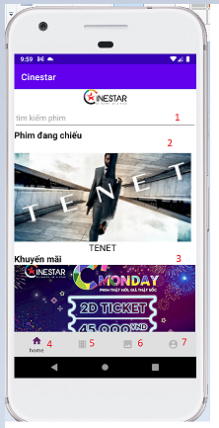

|  |  |  |
| --- | --- | --- |
| No | Name | Description |
| 1 | Search movie | Search movie |
| 2 | movie | Click to detail movie page |
| 3 | Promotion | Click to detail promotion |
| 4 | Home | Click to home page |
| 5 | Movie | Click to movie page |
| 6 | News | Click to news page |
| 7 | Account | Click to account page |

1. News page

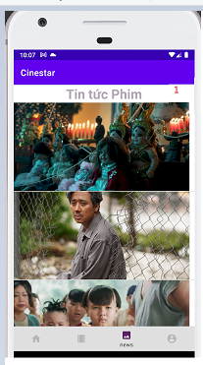

|  |  |  |
| --- | --- | --- |
| No | Name | Description |
| 1 | news | Click to detail news page |

1. Movie page

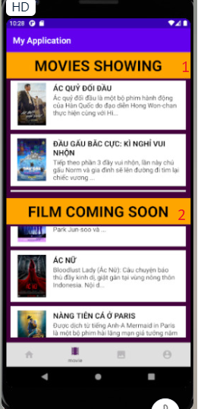

|  |  |  |
| --- | --- | --- |
| No | Name | Description |
| 1 | Movie showing | Click to detail movie showing page |
| 1 | Film coming soon | Click to detail movie coming soon page |

1. Movie detail page

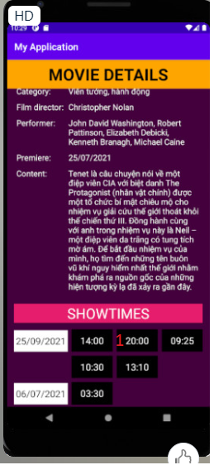

|  |  |  |
| --- | --- | --- |
| No | Name | Description |
| 1 | Show time | Click to ticket page |

1. Ticket page

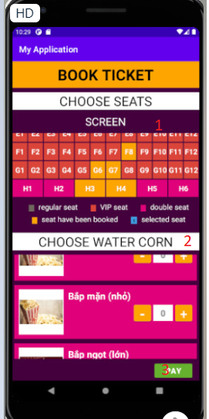

|  |  |  |
| --- | --- | --- |
| No | Name | Description |
| 1 | Choose seats | Click to choose seats |
| 2 | Choose watercorn | Click to choose water corn |
| 3 | pay | Click to pay page |

1. Pay page

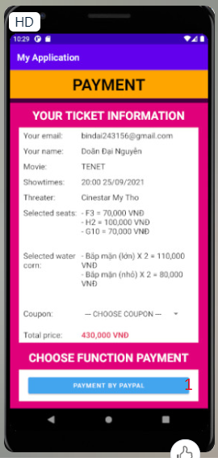

|  |  |  |
| --- | --- | --- |
| No | Name | Description |
| 1 | Payment by paypal | Click to pay with paypal |

### 7.Wheel spin page

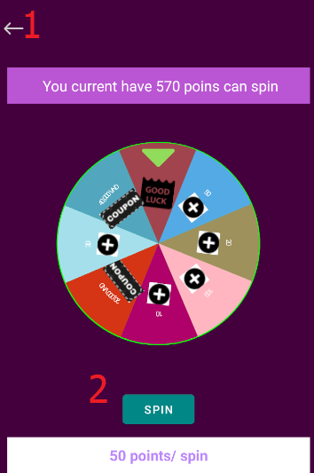

|  |  |  |
| --- | --- | --- |
| No | Name | Description |
| 1 | Back | Back to profile page |
| 2 | Spin | Click to spin |

### 8.Profile page

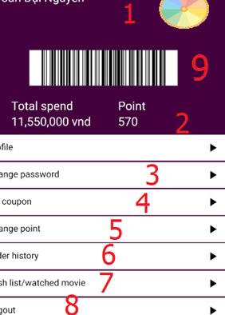

|  |  |  |
| --- | --- | --- |
| No | Name | Description |
| 1 | LuckyWheel | Click to go wheel spin page |
| 2 | Change Profile | Click to go to changeprofile page |
| 3 | Change Passowrd | Click to go change password page |
| 4 | My coupon | Click to go to coupon page |

|  |  |  |
| --- | --- | --- |
| 5 | Change point | Click to go to change point page |
| 6 | Order hisotry | Click to go to order history page |
| 7 | Wishlist/watched listmovie | Click to go to Wishlist/watched listmovie page |
| 8 | Logout | Click to logout |
| 9 | Barcodemembershipcard | Barcode(membershipcard) |

### 9.Coupon list page

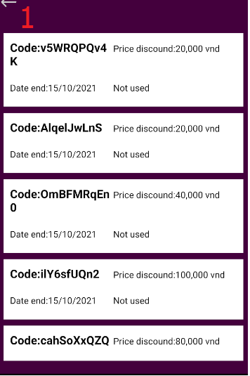

|  |  |  |
| --- | --- | --- |
| No | Name | Description |
| 1 | Back | Back to profile page |

### 10.Change point page

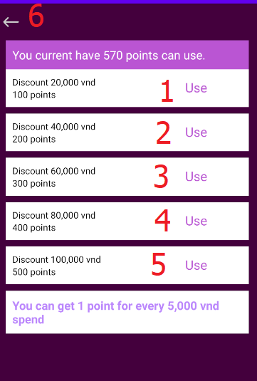

|  |  |  |
| --- | --- | --- |
| No | Name | Description |
| 1,2,3,4,5 | Use | Click to change point |
| 6 | Back | Back to profile page |

### 11.Order history

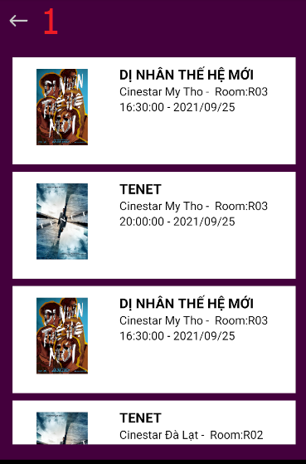

|  |  |  |
| --- | --- | --- |
| No | Name | Description |
| 1 | Back | Back to profile page |

### 12.Ticket detail

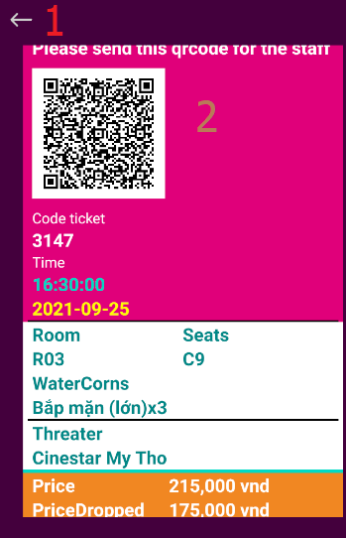

|  |  |  |
| --- | --- | --- |
| No | Name | Description |
| 1 | Back | Back to order history page |
| 2 | Qrcode |  |

### 13.Wishlist and watched list movie

#### 13.1 WishList

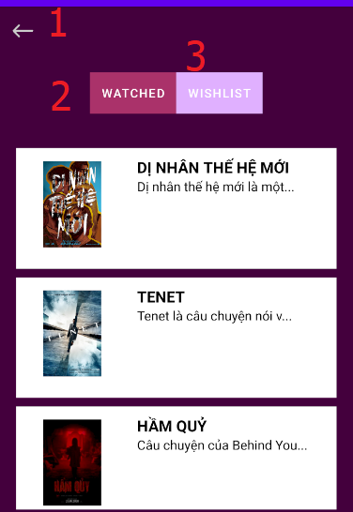

|  |  |  |
| --- | --- | --- |
| No | Name | Description |
| 1 | Back | Back to profile page |
| 2,3 | Tablayout wishlist/watched | Click to go to fragment wishlist/watched list movie |

13.2 watched

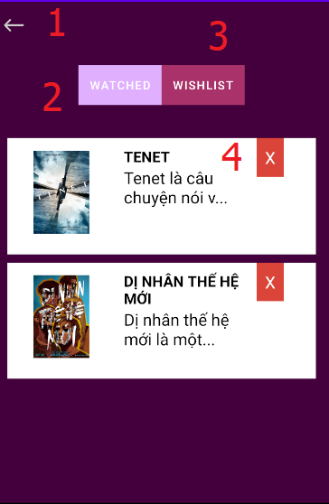

|  |  |  |
| --- | --- | --- |
| No | Name | Description |
| 1 | Back | Back to profile page |
| 2,3 | Tablayout wishlist/watched | Click to go to fragment wishlist/watched list movie |
| 4 | Remove | Click to remove movie out of wishlist |

### 14.Change password

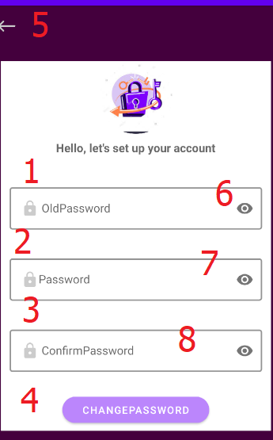

|  |  |  |
| --- | --- | --- |
| No | Name | Description |
| 1 | oldpass | Input old pass |
| 2 | password | Input pass |
| 3 | confirm | Input confirm |
| 4 | Changepassword | Click to change pass |
| 5 | Back | Click to back profile page |
| 6,7,8 | Show/hide password | Click to show/hide password |

### 15.Login page

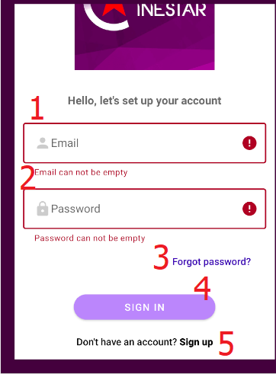

|  |  |  |
| --- | --- | --- |
| No | Name | Description |
| 1 | Email | Input email |
| 2 | Password | Input pass |
| 3 | Forgot | Click to go to forgot page |
| 4 | Sign in | Click to sign in |
| 5 | Sign up | Click to go to sign up page |

### 16.Forgot page

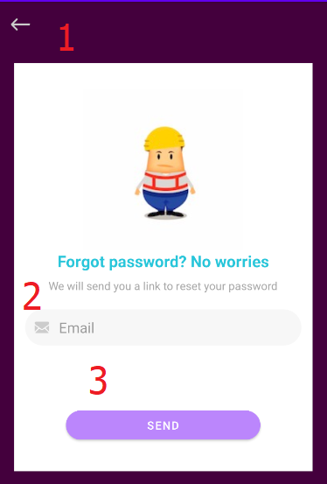

|  |  |  |
| --- | --- | --- |
| No | Name | Description |
| 1 | Back | Click to back to signin page |
| 2 | Email | Input email |
| 3 | Send | Click to get link reset password |

### 17.Sign up page

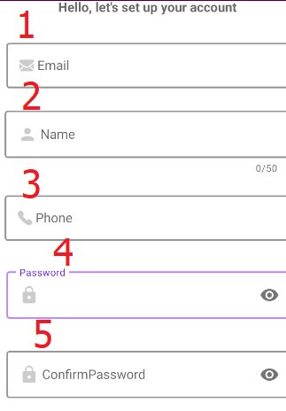

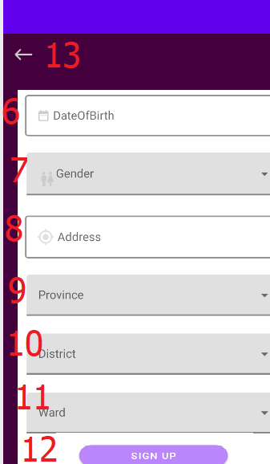

|  |  |  |
| --- | --- | --- |
| No | Name | Description |
| 1 | Email | Input email |
| 2 | Name | Input name |
| 3 | Phone | Input phone |
| 4 | password | Input pass |
| 5 | confirm | Input confirm |
| 6 | Dateofbirth | Input date of birth |
| 7 | Gender | Input gender |
| 8 | Location | Input location |
| 9 | Province | Input province |
| 10 | District | Input district |
| 11 | ward | Input ward |
| 12 | signup | Click to signup |
| 13 | Back | Click to back signin page |

### 18. Profile page

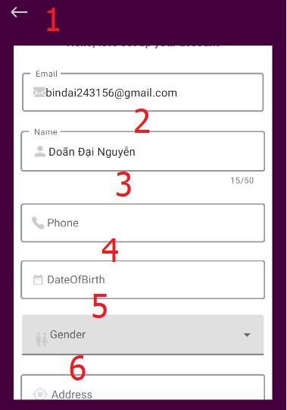

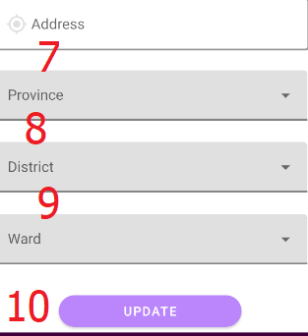

|  |  |  |
| --- | --- | --- |
| 1 | Back | Click to back signin page |
| 2 | Name | Input name |
| 3 | Phone | Input phone |
| 4 | Dateofbirth | Input date of birth |
| 5 | Gender | Input gender |
| 6 | Location | Input location |
| 7 | Province | Input province |
| 8 | District | Input district |
| 9 | ward | Input ward |
| 10 | update | Click to update |